Weifeng Lai (NUID: 001561798)

**Program Structures & Algorithms**

**Fall 2021**

**Assignment No. 3**

**Part1**

The screenshot of Unit test `UF_HWQUPC_Test`:

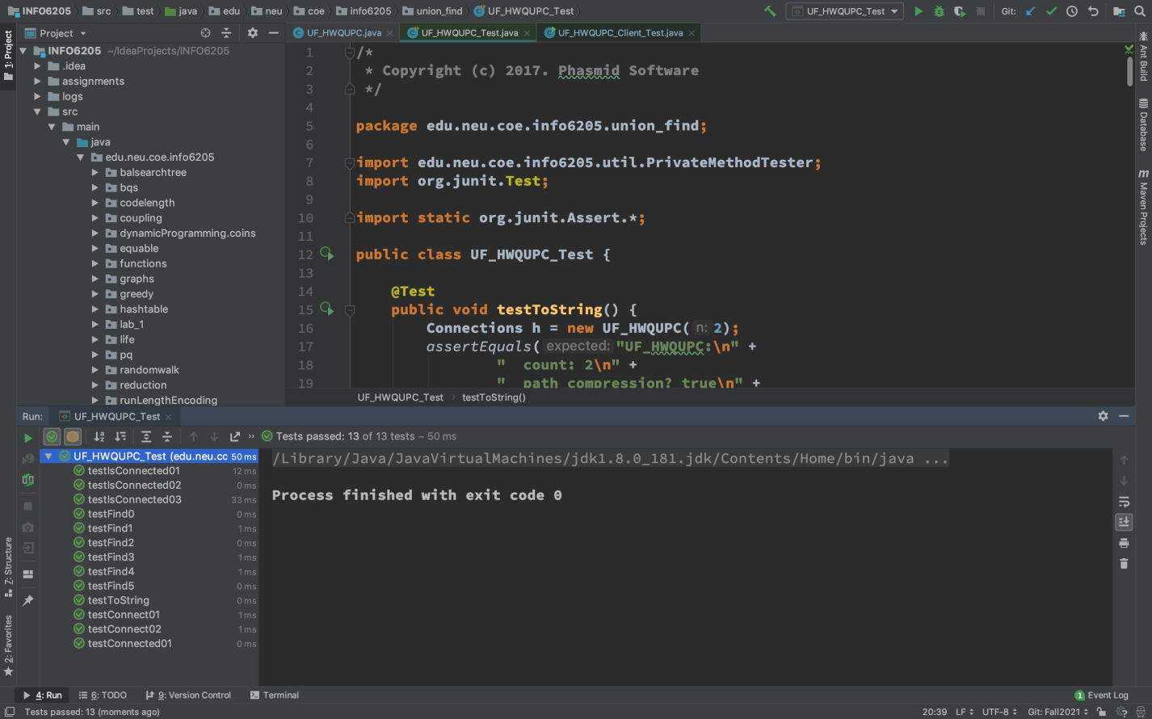

Picture 1 Screentshot of passing UF_HWQUPC_Test

**Part2**

Implemented target functions such as main() and count() by the requirement in file `UF_HWQUPC_Client_Test`:

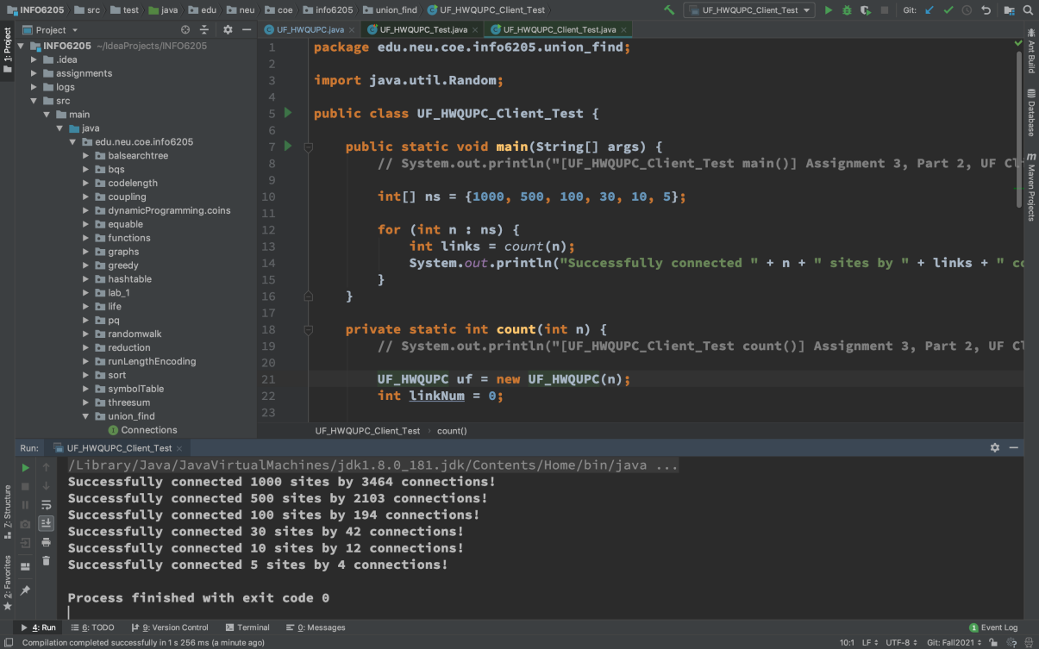

Picture 2 Client code of Part 2

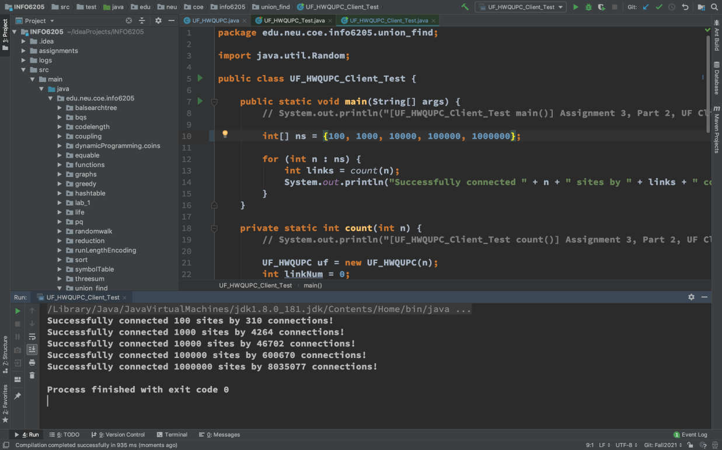

Picture 2 Client code of Part 2

After developed this code, we gather output result here:

Connected 1000000 sites by 8035077 random pairs

Connected 100000 sites by 600670 random pairs

Connected 10000 sites by 46702 random pairs

Connected 1000 sites by 3464 random pairs

Connected 500 sites by 2103 random pairs

Connected 100 sites by 194 random pairs

Connected 30 sites by 43 random pairs

Connected 10 sites by 12 random pairs

Connected 5 sites by 4 pairs

**Part3**

I drew a table which records the number of site(s) in graph (represented by variable n) and the number pair(s) (represented by variable m) to make sure all sites are connected or we say in the same union, as following:

|  |  |
| --- | --- |
| **n** | **m** |
| **5** | 4 |
| **10** | 12 |
| **30** | 43 |
| **100** | 194 |
| **1000** | 3464 |
| **10000** | 46702 |
| **100000** | 600670 |
| **1000000** | 8035077 |

Table 1 Result between the number of objects (n) and the number of pairs (m)

And We drew these points from table 1 on scatter plot, and fitted curve, where (X, Y) coordinate respectively represents the number of sites and the number of random pairs that make these site all be connected, as flowing:

Table 3 Scatter plot made from data points (n, m) of table 1

From this test result, I assume that the relationship between the number of objects (n) and the number of pairs (m) is: O(n) <= m <= O(n·lgn)